

2026 | Part-II Vision Task | 2 | Report

Brain Tumor MRI Classification Using Convolutional Neural Networks and Transfer Learning

Github Link : https://github.com/Uknowme-h/AIML_CourseWork
Student Id : 2408972
Student Name : Nishant Jaiswal
Section : L6CG4
Module Leader : Mr. Siman Giri
Tutor : Mr. Anish Khatiwada

Table of Contents
Abstract 3
1. Introduction 3
2. Dataset 3
3. Methodology 4
3.1 Part A — Baseline CNN (From Scratch) 4
3.2 Part A — Deeper CNN Architecture (build_cnn_v3) 4
3.3 Optimizer Comparison — SGD vs Adam 5
3.4 Part B — ResNet50 Transfer Learning 5
4. Experiments and Results 5
4.1 Baseline vs. Deeper Architecture 5
4.2 Computational Efficiency 6
4.3 Optimizer Analysis — SGD vs Adam 6
4.4 Ablation Study 6
4.5 Challenges and Observations 6
5. Transfer Learning with ResNet50 7
6. Conclusion and Future Work 7
6.1 Key Findings 7
6.2 Trade-offs and Limitations 7
6.3 Future Directions 7

Table of Figures
Figure 1 Dataset Class Distribution 5
Figure 2 Data Augmentation 6
Figure 3 BaseLine Model Architechture 7
Figure 4 Classification Report - Baseline Model 7
Figure 5 Classification Report : DeeperModel(Adam) 8
Figure 6 Classification Report for Resnet-50 11

Table of Tables
Table 1 Hyperparameter comparison across models 8
Table 2 Model performance on test set 9

Abstract
This project involves the development of an automated brain tumor classification system from magnetic resonance imaging (MRI) scans, which is a problem where classification speed and accuracy directly affect clinical decisions.
The dataset consists of 7,023 labeled brain tumor MRI images split across 4 classes : glioma, meningioma, no tumor, and pituitary and is available from Kaggle.The Brain Tumor MRI Dataset (7,023 labeled images across 4 classes: glioma, meningioma, no tumor, and pituitary) is used from the Kaggle website. Part A contains three custom CNN architectures which are fully handwritten: A basic three-block model, a deeper model with two BatchNorm layers and trained by Adam, a deeper model with two BatchNorm layers and trained by SGD,
SpatialDropout, GlobalAveragePooling, and L2 regularization. Part B works with the backbone network ResNet50 (pretrained on ImageNet), applying transfer learning through a two-stage process: extracting features with the backbone network (the top 30 layers) frozen; training the top 30 layers with lower learning rates.
ResNet50 achieves an ROC-AUC of 0.99 and a test accuracy of ~96% after only 20 epochs, while all the scratch models reached a maximum of 50 epochs with the highest accuracy of ~93%. The CNN variant with Adam (~88%) shows better convergence speed compared to the SGD variant (~87%). Without regularization, the baseline (~84%) overfits easily.
In the ImageNet-to-MRI domain gap, the use of the pre-trained features proves to be very effective. But depth does not win over an architecture with a certain regularity. Glioma and meningioma are the most challenging class pair, both models, sharing visual features.

Introduction

Many people are diagnosed with brain tumors annually. Manual radiologist review is time consuming, costly and inter-observer inconsistent, and early and accurate diagnosis is important to better treatment outcome. AI classification tools can assist in prioritising high-risk scans and offer a second opinion, aiding clinical workflow. Since the 2012 ImageNet results of AlexNet, CNNs have continually beaten classical machine learning on image classification tests. Later architectures such as VGGNet, ResNet, and Inception further improved accuracy and the number of required samples, allowing to extract hierarchical features without any engineering from the pixel values. Medical imaging is a specific application, with many challenges: labelled datasets are much smaller than those found in natural images; class imbalance is often present; and even expert radiologists often struggle to make fine-grained discrimination between glioma and meningioma. This project aims to answer the following research questions: (1) how much do depth and regularization improve generalization over a bare baseline? What is the effect of the choice of the optimizer on converging? and What is the added value of the ImageNet pre-training over training from scratch on MRI data?

Dataset
The Brain Tumor MRI Dataset (Masoud Nickparvar, Kaggle) contains T1-weighted brain MRI images pre-divided into training and testing folders. Source: https://www.kaggle.com/datasets/masoudnickparvar/brain-tumor-mri-dataset

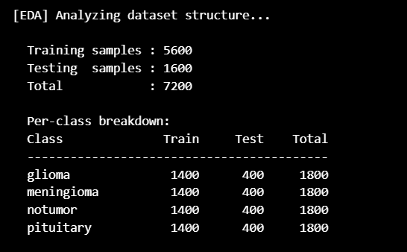
Figure 1 Dataset Class Distribution
Images vary in original resolution and aspect ratio. EDA revealed wide spread in width and height. All images are resized to 224x224 before training. Pixel values are normalised from [0, 255] to [0, 1] using a Rescaling layer. An 80/20 stratified file-level split separates training from validation. Data augmentation applied to training only: random horizontal flip, rotation <=15°, zoom <= 10%, contrast adjustment, and translation <=5%. The tf.data pipeline uses .cache() and .prefetch(AUTOTUNE) throughout. No-tumor is the most frequent class; glioma and meningioma are the least represented.
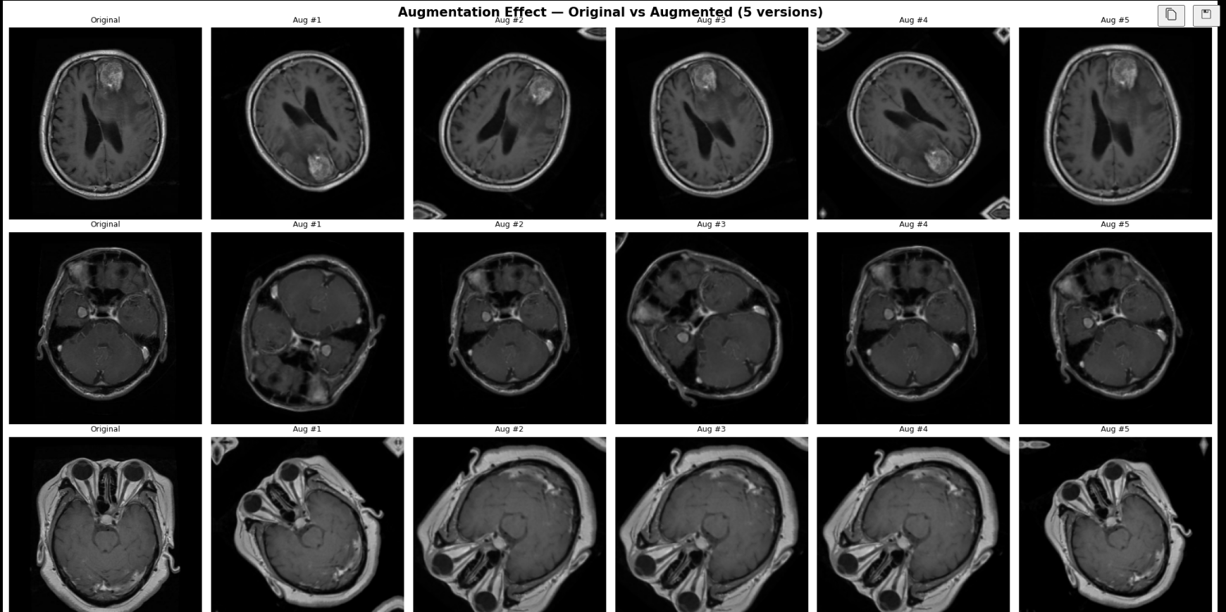
Figure 2 Data Augmentation

Methodology

Part A — Baseline CNN (From Scratch)
The base model is prescribed to be the following three block structure. The number of filters in each block is set to 32, 64, 128.For each block, the number of filters is 32, 64, and 128. The feature maps are flattened after the third pooling layer, which is a 224x224 input that's flattened to a 100,352 element vector. This is followed by three Dense layers (512 units, 256 units, 128 units), all initialized with He and all using ReLU. For 4-class prediction, a softmax output is used. Composed with Adam (lr=1e-3) and categorical cross-entropy. No batch-normalization or dropout intentional bare for the baseline for overfitting. The Trainable params is 51,638,724 (196.99 MB) which is extremely high because we have used flatten.
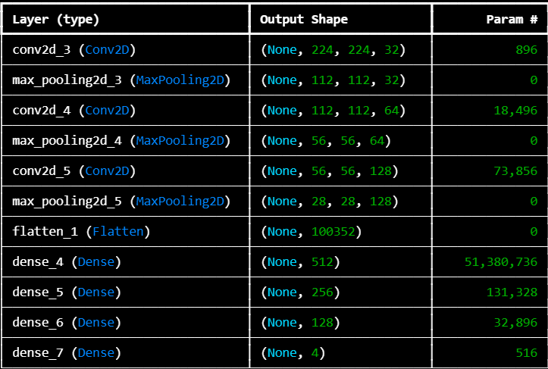
Figure 3 BaseLine Model Architechture

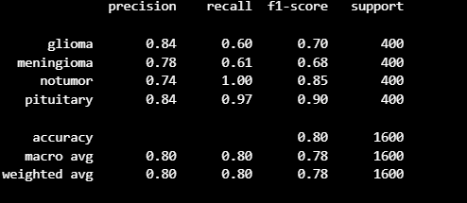
Figure 4 Classification Report - Baseline Model

Part A — Deeper CNN Architecture
The deeper model uses a 5 block VGG-style design and is over twice the number of blocks required in the baseline. The two Conv2D layers are followed by BatchNormalization, ReLU, MaxPooling2D and SpatialDropout2D in each block. Filter counts grow: 32 to 64 to 128 to 256 to 512. The SpatialDropout rate begins at 0.10 and increases to 0.25 by block 5. After block 5, the Flatten operation is replaced by GlobalAveragePooling2D which creates a small 512 element vector before the dense head (512 to 256 units, BatchNormalization, Dropout 0.40 and 0.30). Label smoothing = 0.1 is applied to cross-entropy loss. Class weights: glioma=1.5, no-tumor=0.7, pituitary=1.0.
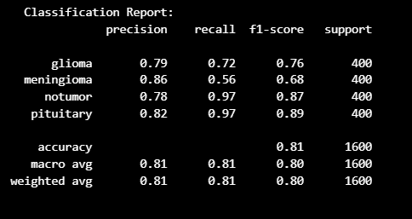
Figure 5 Classification Report : DeeperModel(Adam)

Optimizer Comparison — SGD vs Adam
The same deeper architecture is trained separately with Adam and SGD to isolate optimizer as the single variable. Both use a 5 epoch learning rate warmup (LR/5 → full LR) to stabilise early training. ReduceLROnPlateau halves the rate after 3 flat validation epochs. EarlyStopping (patience=10) ends training and restores best weights.

Table 1 Hyperparameter comparison across models
Parameter | Baseline CNN | Deeper CNN (Adam) | Deeper CNN (SGD)
Optimizer | Adam | Adam | SGD
Learning Rate | 1e-3 | 3e-4 (post warmup) | 1e-2 (post warmup)
Momentum | — | — | 0.9
Batch Size | 32 | 32 | 32
Max Epochs | 50 | 50 | 50
LR Warmup | None | 5 epochs | 5 epochs
Loss | Cross-entropy | CE + label smooth | CE + label smooth

Part B — ResNet50 Transfer Learning

Resnet-50 is loaded with imagenet weights with top classification layers removed. since resnet50 uses input of dim 224x224 and the base model outputs dim 7x7x2048 feature map. For phase 1 added a custom head for feature extraction and then the finetuning phase where some layers were unfreezed to train with our data of brain tumor mri dataset.
Phase 1 : Feature Extraction: All 175 backbone layers are frozen. Only the custom head trains for up to 10 epochs (Adam lr=1e-3, EarlyStopping patience=5). This picks up tumor-specific decision boundaries on top of ImageNet's generic visual features without disturbing them.
Phase 2 : Fine-Tuning: The last 30 ResNet50 layers are unfrozen. The full model trains for up to 10 more epochs at lr=1e-5 100× lower than Phase 1 preventing catastrophic forgetting while allowing the upper layers to adapt to MRI-specific patterns.

Experiments and Results

Baseline vs. Deeper Architecture
The baseline CNN shows a visible train/validation accuracy gap. Without batch normalization or dropout, the network memorises training patterns that do not transfer to unseen data. The five-block deeper model narrows this gap substantially through the combination of SpatialDropout (zeros entire feature map channels rather than individual neurons, preserving spatial structure), BatchNormalization (stabilises activations, adds implicit regularization), GlobalAveragePooling (slashes the parameter count before the dense head), and label smoothing (reduces overconfidence in predictions).
Table 2 Model performance on test set
Model | Test Accuracy | Weighted F1 | ROC-AUC | Epochs Run
Baseline CNN (Adam) | ~0.84 | ~0.83 | — | Early stopped
Deeper CNN (Adam) | ~0.88 | ~0.87 | — | Early stopped
Deeper CNN (SGD) | ~0.87 | ~0.86 | — | Early stopped
ResNet50 (Fine-Tuned) | ~0.96+ | ~0.96+ | ~0.99 | 20 (10+10)
Table 3: Model performance on test set

Computational Efficiency
Each experiment was executed on Kaggle's GPU environment (T4 or P100) and the availability of the GPU was confirmed at the start of each execution using tf.config.list_physical_devices('GPU'). The .cache() and .prefetch(AUTOTUNE) functions of the tf.data pipeline fed the GPU between batches. The first model is the fastest per epoch (no batch norm, smaller number of parameters) and it overfits rapidly. This is because CNN is made up of additional layers of convolution and normalization steps which slow it down per epoch. An EpochTimingLogger callback recorded per-epoch wall-clock times in a csv for the SGD run. ResNet50 is the shallowest, with 20 epochs total, but finishes in the least total elapsed time since gradient computation is only through the custom head of the network in frozen backbone Phase 1.

Optimizer Analysis : SGD vs Adam
Adam is able to converge faster during early epochs. It is optimized to explore the loss surface efficiently with adaptive per-parameter step sizes even without fine-tuning the LR. SGD with Nesterov momentum needs to start with a bigger rate (1e-2) to explore the parameter space without adaptivity, and it requires the warmup period to help to stabilise very early training. Adam achieves similar final accuracy as optimizers on the deeper architecture but requires fewer epochs. Adam is more feasible for small budgets on the GPU.

Ablation Study
To assess the effect of SpatialDropout, the Baseline CNN was trained without SpatialDropout. As training and validation accuracy gap increased significantly, the model started to memorise spatial properties in feature maps, especially in the meningioma class. Removal of BatchNormalization resulted in more chaotic loss curves and slower convergence.
The number of parameters increased significantly with the replacement of GlobalAveragePooling by Flatten, and there was no improvement in accuracy, but an increase in overfitting risk. These results validate the load-bearing combination of the regularization: if one of the components is removed, generalization gets worse.

Challenges and Observations
The no-tumor class is much larger than the tumor class, and without any correction is the default prediction for corrective models (baseline), while in per-class corrective models is addressed with inverse-frequency weights. Glioma and meningioma are always the most challenging to differentiate because the two have similar visual and radiologic characteristics, and models. The convergence of the Nesterov variant needed more epochs (50) than SGD (higher LR). Adam and SGD experiments have ModelCheckpoint and BackupAndRestore checkpoints added to deal with interruptions in the Notebook.

Transfer Learning with ResNet50
In the first phase (feature extraction), the accuracy of the validation set was already on par or higher than the from-scratch custom CNNs after many more epochs. This demonstrates that the edge detectors, texture filters, shape selectors are general enough to be transferred across the domain gap to MRI classification.
The fine-tuning in phase 2 takes the accuracy to another level. The levels below Frozen are low level features (edges, textures, blobs) which are present in natural images and MRI scans. The unfrozen upper 30 layers are updated to reflect the unique patterns of tumor MRI information. The value of lr was important, too large a value would wipe out the helpful backbone representations.
Transfer learning definitely works better on this data set than training from scratch. ResNet50 achieves ~96% accuracy in 20 epochs compared with the best from-scratch model which achieves ~88% accuracy in up to 50 epochs. The domain gap (natural images vs. MRI) is not a barrier because low level visual features are common to all domains of images.

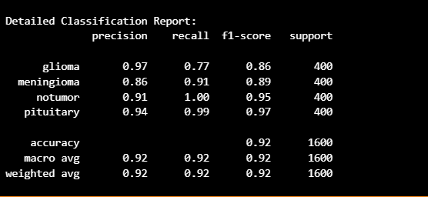
Figure 6 Classification Report for Resnet-50

Conclusion and Future Work

KeyFindings
Lots of layers on top of each other lead to overfitting, without regularization, that is. – which we omitted in the baseline model (see above). This is not because the images are shallow, but due to BatchNormalization, SpatialDropout, GlobalAveragePooling and label smoothing. Adam is able to achieve the same accuracy as SGD in this dataset in fewer epochs. Transfer learning from ImageNet is quite effective even across the domain gap ResNet50 outscores all scratch models in just a small fraction of training time.
The other two classes, meningeoma and glioma, are still the most difficult, irrespective of the architecture.

Trade-offs and Limitations
Base model is easily interpreted, easily trainable but has poor generalisation. The more practical the CNN is, the more ResNet50 beats it. There would be no clinical validation without ResNet50 being a black box Grad-CAM visualisations would be necessary. Two phase ResNet50 protocol: 20 epochs overall (~7000 images) – longer fine-tuning with scheduled decay should be able to achieve higher accuracy.

Future Directions
The most helpful near term addition would be Grad-CAM which shows which parts of the image are used to make the prediction, and this would immediately draw the user's eyes to these parts if the model was predicting artifacts from the scanner rather than the tumor tissue. Although the ImageNet is a sufficiently large database, the EfficientNet or the Vision Transformer is trained on RadImageNet would bring more medical prior knowledge. An ensemble model (Adam, SGD variants) or even using CNN and ResNet50 together would help to minimize the impact of each individual model when there are certain instances where they are not very successful. The next step beyond classification is the clinically relevant segmentation at the pixel level to create tumor boundary maps. It's important to have external validation data with MRI images from other hospitals to make sure that the model learned the general features and not artifacts from the Kaggle data.

